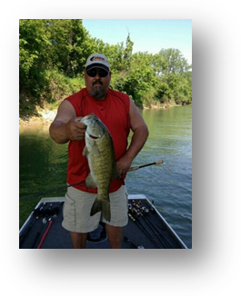
Name: Jim Stone
City: Greenwood,In
Boat: Triton Co-Angler
Favorite Lake: Raccoon
Favorite Bait: Tube
Largest fish caught in Indiana: 6.93# Monroe
Favorite Reel: Daiwa TypeR Zillion
Favorite Rod: G Loomis NRX
Favorite crankbait: Bill Norman Little N
What way do you like to fish best: Football Jig out deep

