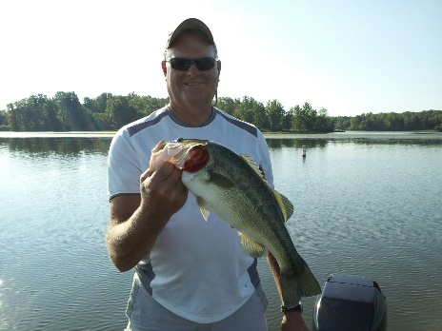
Name: Rex Harris
City: Bargersville,In
Boat: Triton TR21 , 200 HP
Favorite Lake: Brookville
Favorite Bait: 10” Zoom O’l Monster worm
Largest fish caught in Indiana: 6# 6oz.
Favorite Reel: Lews Tournament Pro 7:7:1
Favorite Rod: G Loomis GLX 7’4”
Favorite crankbait: Hand painted Holographic 1.5 DD in sexy shad
What way do you like to fish best: Run/gun
