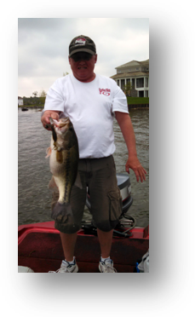

Name: Mark Goulding
City: Indianapolis,In
Boat: Fisher 14’ V Hull
Favorite Lake: Elk Creek
Favorite Bait: Senko
Largest fish caught in Indiana: 5.8#
Favorite Reel: Shimano
Favorite Rod: St. Croix
Favorite crankbait: Lipless Red Eye Shad
What way do you like to fish best: Slow!

