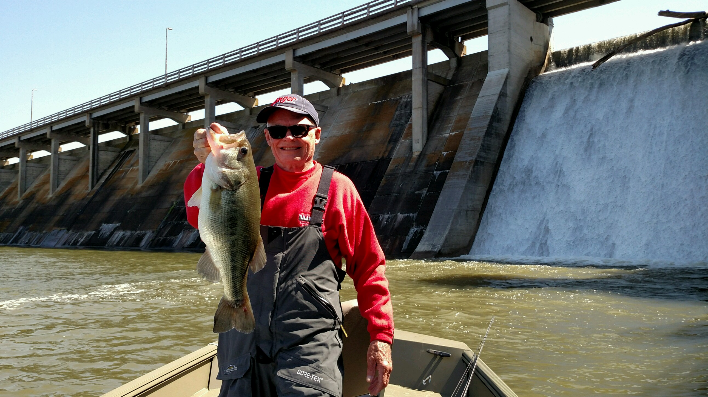

Name:
City
Boat:
Favorite
Favorite Bait:
Largest fish caught in Indiana:.
Favorite Reel:
Favorite Rod:
Favorite crankbait:
What way do you like to fish best:

