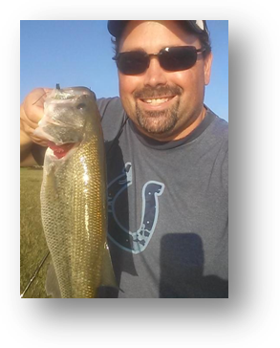
Name: Brett Miner
City: Fishers,In
Boat: Triton Co-Angler
Favorite Lake: Geist
Favorite Bait: Strike King Rage Craw
Largest fish caught in Indiana: 6#
Favorite Reel: Bass Pro Shops Pro Qualifier
Favorite Rod: Fenwick Silver Hawk
Favorite crankbait: KVD 1.5
What way do you like to fish best: Crankin and Flippin

